SEP Project Proposal
Project Title | AI-Powered Gym Management System
Team Members: | 1. Aayush Shah  2. Darpan Subedi  3. Riwaj Khadka  4. Ankit Das  5. Aayush Shah  6. Nauraj Khawas
Project Overview
The fitness industry in our country Nepal has grown significantly in recent years, especially in cities such as Biratnagar, Kathmandu, Dharan, Itahari, etc. However, many gyms still rely on manual record books, notebooks system or Microsoft Excel to manage their memberships, attendance, trainer assignments, and workout records.

These traditional methods often lead to misplaces of records, inaccurate attendance tracking, delayed memberships renewals, and difficulty in providing personalized fitness guidance to members. Many gyms also lack affordable software that helps their daily operations.

To address these challenges, we propose an AI-Powered Gym Management System, a web-based application that digitalized gym management while using Artificial Intelligence to recommend personalized workout plans based on member’s age, BMI, fitness goals, and experience level. This system will help gym owners improve efficiency while giving members a better fitness experience.

Objectives:
The project aims to:
- Develop an easy-to-use Gym Management System for gyms in Nepal.
- Store member information securely using a MySQL database.
- Digitize attendance, membership, and trainer management.
- Use AI-based workout recommendations suitable for Nepali gym users.
- Generate reports for gym owners and administrators.
- Demonstrate practical integration of Artificial Intelligence with database Management.

Tools and Technologies used:
Frontend
- HTML5
- CSS3
- JavaScript

Backend
- Python (Flask)

Database
- MySQL

Artificial Intelligence
- Python
- Rule-Based Recommendation System

Version control
- Git and GitHub

Development Environment
- Visual Studio Code
- Xampp

Core Features
User Authentication
- Secure Login
- User Registration
- Password Encryption

Member Management
- Register Members
- Edit Member Details
- Membership renewal
- Delete Members

Attendance Management
- Daily Attendance
- Monthly Attendance Report

Trainer Management
- Add trainers
- Assign trainers
- Trainer profiles

Workout Management & AI Recommendation
- Workout History
- Personalized Workout Plans
- BMI-Based Suggestions
- Goal-Based Recommendations

Dashboard & Reports
- Total Members
- Active Memberships
- Daily Attendance
- Monthly Reports
- Membership Reports
- Attendance Reports
- Workout Reports

Activities and timescales
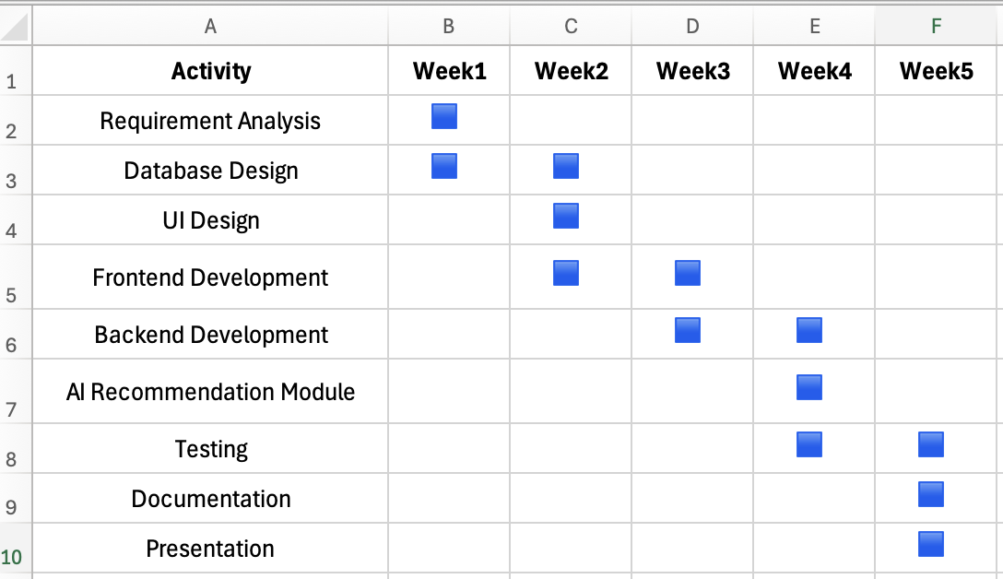

Expected Outcomes
After completing this project, we expect to deliver.
- A working web-based Gym Management System.
- A secure MySQL database for managing gym records.
- A beginner friendly AI module that recommends workout plans.
- A functional prototype suitable for gyms in Nepal.
- Improved understanding of Artificial Intelligence and Database integration.
- A project that can be demonstrated successfully during the final SEP evaluation.

GitHub repository:
https://github.com/aayushofficial-dev/AI-Powered_GymManagementSystem

